Getting the most from your website.
Easy steps to help take your website to the next level.
Contents
Introduction 2
Website Effectiveness 3
The Right Content 3
Video 3
Web Analytics 4
Search 5
Content 5
On-site Optimizations 5
Backlinks 6
Expanding your Online Presence 7
Google My Business 7
Facebook® 8
Twitter 9
Online Marketing 10
Paid Search Engine Marketing 10
Social Marketing: Facebook 11
Social Marketing: Instagram 12
Conclusion 13

Introduction
Are all websites equal?
The short answer is no—your website should be helping you gain greater online exposure, generate leads and drive customers through your door. Websites optimized for usability and online marketing can ultimately mean more revenue for your business, by ranking higher in search, getting found by more people, and securing customers.
A strong online presence answers “YES” to the following questions:
- Does your website offer a good experience on a desktop, tablet and mobile device?
- Is your website optimized to show up on popular search engines?
- Does your website include elements to engage with visitors and keep them on your site longer than average?
- Is your website tracking visitor behavior to determine where improvements can be made?
- Is your website or business appearing on relevant sites and social properties?

How can I get the most out of my website?
Good news! There are some areas you can quickly and easily focus on that will help boost your online exposure and convert online visitors into paying customers.
Here’s what you should focus on:
 | Website Effectiveness | Search | Online Presence & Marketing
What does it mean? | - Do you have the right information on your site?  - Are you keeping your content fresh and up-to-date?  - Are you engaging with your customers?  - Are you tracking visitor behavior? | - Are you creating and building link value on your website?  - Is your business found online? | - Did you link your social media accounts to your website?  - Are you expanding your visibility with flexible paid advertising options?
How can I improve? | - Ensure visitors find what they’re looking for  - Add a video(s) to your website  - Web Analytics | - Applying best practices with website content  - Adding metadata  - Increasing backlinks to your website | - Facebook page  - Twitter page  - Google My Business  - Paid search and social marketing
Keep reading to learn more about easy steps you can take to help take your website to the next level.
This guide will go through each component in detail with one goal in mind: to educate you on the various ways in which you can improve your online presence and get more eye balls on your website.
Let’s get started!

Website Effectiveness

The Right Content
Making sure visitors to your website find what they need to know.
It’s great that you have a website up for your business—a professional-looking website adds credibility to your business and drives customers through your doors.

Do a scan of your website to make sure the top customer questions are answered and easy to find:

- How do I contact you?
- What is your phone number?
- What are your hours of business?
- Where are you located?
- What products/services do you offer?
A March 2017 survey revealed that the top reasons consumers leave a small business website is because of a bad impression made by outdated contact information (nearly 50%) and lack of address/directions/business hours (42%). Ensure your contact information appears on your header or above the fold on every page, and that your address/map is easily found. Key pieces of contact information to include:
- Phone number near the top of every page
- Physical address & map
- Directions
- Hours of operation and after hours contact
- Link to send an email or email addresses for different points of contact

Consider: what do you want visitors to your site to do?
What is the main objective of your website? This answer is dependent on your business and industry—is it to call and make an appointment? Make an immediate online purchase? If retail or restaurant, to visit?
The goal of your website should be front and center, with a prompt to “Call now and book an appointment”, “Buy now” or Location link visible at the top of your website.

Video
Using video to draw the attention of your visitors.
A website has 10 seconds to capture a visitor’s attention.

People are so accustomed to consuming video content that it’s become the preferred medium for learning, staying entertained and seeking out new information—especially on mobile devices.

A great video captures the mood of your business, and more importantly it simplifies your message, so your visitors remember you.

Don’t have the budget to create a professional business overview video? Don’t worry, there are plenty of affordable solutions out there.

- Client testimonials. Ask your top customers for feedback on the experience they’ve had with your products and services and capture it in a video that can be posted on one of your website pages.

- Vlogs. Vlogs or video blogs are also becoming very popular among small business owners. These types of videos can be used to do a “show and tell” on what you are working on, showcase your latest products, or anything else that may be relevant to your visitors.

- Industry-related videos. You can source a video on YouTube that showcases industry trends, highlights, or any other relevant and newsworthy updates that your audience would find interesting. Once you have found a fitting video simply embed it into one of the pages, and make sure to provide the source name.

Web Analytics
Stay in the know with Web analytics.
Web analytics are a critical piece to understanding how visitors are using your website and what areas can be improved. A web analytics tool analyses your website and provides you a report of key metrics including:
- Visitor information (frequency of visits, new vs. returning, country, etc.)
- Where did they come from?
- What did they do on your website?
- Where did they go after your visiting your website?
Why should you care?
By understanding who visits your website, where they are coming from, how frequently they visit and where they go afterwards, you can optimize your website to improve online experience and increase revenue.
Which tool should you use?
There are many free and paid analytics tools available. As part of your website package, you are able to get valuable insights into your website traffic with statistics like visits, duration on page, bounce rate, click paths, origin and more.
If you want a more advanced tool, you can set up Google Analytics, as it is a popular choice for business owners. Plus, the set-up process is easy and free.
Step 1: Sign up for Google Analytics. You will need a Google account and your website information handy.
Step 2: Add the tracking code to your website. (Note: In Online Presence Builder, you can add your Google Analytics tracking code under “Site Settings”.)
Step 3: Learn about your audience.
For more information, check out Google’s Analytics Training and Support.

Search
In order to remain competitive, your website needs to be found online when and where potential customers are searching. Most often, this means when customers search for your industry or the services you offer in your area through Google or another search engine, your business needs to show up in the search engine results.
There are a number of things you can do to improve your search engine results.

Content
Power your site with engaging content.
Having helpful, relevant content is vital to building a successful website that will attract visitors and drive more business. Your site content helps search engines like Google determine whether your website is credible and what searches it should appear for. Be sure to research key words related to your industry and include those words in your content. For consideration:
- Tailor your content to appeal to your target customer
- Include content that is important and compelling for your market
- Differentiate your value proposition (why us?) from competitors
- Build pages to incorporate relevant keywords
  - Company name and key people
  - Names/types of products or services
  - Geographic area served
  - Keywords that address the ‘symptom’ as well as the ‘cure’ (auto mechanic/squeaky brakes)
Here are some areas of your website where you can include interesting and relevant content:
- Products and/or Services. Including a list or description of the products and/or services your business offers can help ensure your business is being found when potential customers are searching for those products or services online.
- Blog. With every blog post that you write, you add an additional indexed page to your website, which helps drive traffic to your site organically. Including industry relevant content helps incorporate key words and phrases on your website. Finally, blogs should regularly have new content, and websites that are more frequently updated can improve their search engine ranking.
- About Us section. Customers like to make emotional connections with businesses. Make sure that you tell your story; how did you start? What’s your mission? How are you different from the competition?
Keeping your website content up to date is also important. Customers are more likely to trust a business with current, relevant content and design on their website—and more likely to dismiss a business with outdated content or dates displayed past a few months. Time elapsed between updates also affects your website’s search ranking in Google and other search engines, as a factor of your website’s credibility and relevance.

On-site Optimizations
Optimize your website for search engines.
Meta tags are pieces of text that describe a page's content in your HTML code. Some metadata has great value, particularly to search engines. Correct use of metadata can improve your placement in search engines, but more importantly how your website appears in a search engine.
In particular, the description meta tag is frequently shown in Google beneath the link to a specific result.
Make sure that all the pages of this website include a meta description.
- Many website design tools include sections where you can edit the meta tags and metadata of your website. Educate yourself on best practices in defining metadata to ensure your website is optimized for search and usability.
- Alternatively, you can consult with a web designer or agency to improve your website’s meta tags and metadata.

Backlinks
Build out your backlinks.
“Backlinks” is an SEO term for links on other websites that link back to your website. Search engines use the number of backlinks to your website as an indication of the popularity or value of a website and its content when determining a search result ranking for a website.
Websites that are being linked to from many respectable sources will achieve higher search results than competing websites with fewer backlinks.
Ways to increase backlinks to your website:
- Online directories. Ensuring your business and website are listed in online and local directories is a great way to obtain quality incoming links. A few examples include Yelp, Yellow Pages and Google My Business.
- Make news. Earning coverage from the local news, bloggers or other local businesses is a great way to earn quality links to your website. Consider contacting local news outlets or local event websites and pitch them news-worthy stories on your business: charity events, contests, giving away something for free, anniversaries, community events or feel-good stories.
- Guest blog posts. Try submitting guest blogs or articles on trusted sites with relevant topics. Writing articles in your area of expertise or about topics of interest published on reputable sites is a great way to create backlinks to your website. Talk to other local businesses in your area about ways you can cross-promote, create community and increase your exposure.
- Testimonials. Writing a testimonial is one way of getting onto websites of other businesses and having them link back to your site. Think about some of the business services or products that you use and consider sending them your testimonial with a link to your website.

Expanding your Online Presence
The new customer journey begins with online searches. You need to ensure your business is visible in the competitive world of search results. Having your business set up on key social networks and platforms with consistent information helps with local SEO and boosts your visibility when potential customers are searching online.

Google My Business
With nearly every consumer searching for local businesses online, it’s crucial for you to claim and optimize your business listing. If you sell products or services within your local area, this is one of the easiest ways to get found on Google Search and Maps.
Google Maps listings often display when customers are looking for specific products and services close to their location.
Here’s how to get started:
- Set up an account with Google (skip to step 2 if you have already registered your business email with Google).
  - Go to: https://www.google.com/business/.
- Click on “START NOW”.
- Sign up using your business email address and information.
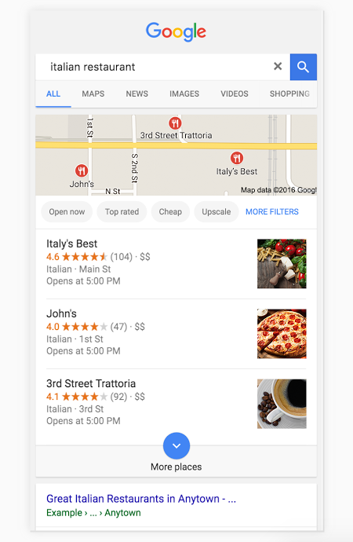
- Find your business.
- Search for your business in the search field by business name and address.
- Once you have found or created your correct business location and category.
- Confirm your business and check “I am authorized to manage this business and I agree to the Terms of Service” and click continue. This will create a Google+ Page for your business.

- Verify your listing.
- Google will need you to verify your business so click on “Mail me my Code”. Your code will be sent to your business location.
- Congratulations! You now have Google My Business set up for your business.

- Manage your listing.
- Add a Profile photo, business hours, contact information, any additional photos, your website, and an intro to your page. Then click “Done Editing”.

Set up your Google My Business listing now—it’s a free and important way to acquire more customer connections.

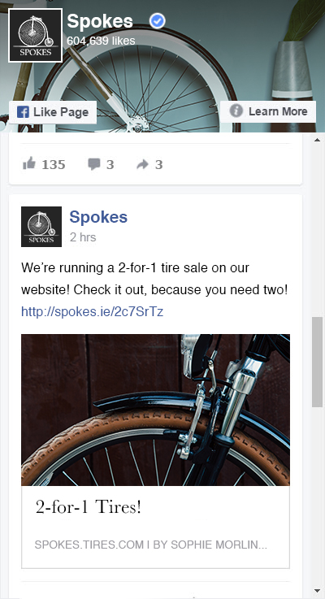
Facebook®
For most small businesses, it’s no longer a question of whether to interact with customers on Facebook®. With more than a billion active users each month, Facebook® is a must for marketing.
Your Facebook® Business page can help drive business in a number of ways, from reaching new customers on social media and staying in front of existing customers, to leveraging the influence of your existing, satisfied customers, to showing prospects that your business is active, engaged and credible.
Create your page:

  - If you’ve never used Facebook®, first sign up for a personal account at facebook.com.
  - Once you have a personal account, go to “Create a Page” to start your business page.
  - Select “Local Business or Place” or one of the other categories (Entertainment, Cause or Community, Company, etc.).
  - Fill out your profile. Include your business name, a cover and profile picture, links to other sites (i.e., your Twitter profile), your hours, website, and contact information. Use the “About” box to tell customers a little more about what you do.

Why is this important?

Facebook® uses your profile information to help people find you via Facebook® Search, so the more you provide, the more easily you’ll be found.

Start talking:

  - You can start posting new content on your page right away.
  - Share some news about your business, upload photos or post a link to an interesting article.
  - Plan to add 1–3 new posts a week to start, and be sure to keep content up to date. If your Facebook® page isn’t frequently updated, customers may not trust that your business is credible.

What type of content works?
Here are some “Do’s” when it comes to engaging Facebook® content.

- 80/20 rule. It’s tempting to fill your Facebook® Page with sales pitches, but resist. Facebook® is great platform for using conversation to build real relationships with customers and prospects, but users aren’t spending time on Facebook® because they want to be marketed to. Use Facebook® to talk to the people who care about your business and keep the sales pitches to a minimum (using the 80/20 rule: 80% content, 20% product).
- Ask questions. It’s human nature to want to respond to a question, so use that urge to get people to comment on your updates. Example: If you sell clothes, post a picture of a sweater in two different colors and ask “Which one do you like more, red or yellow?” Be sure to engage with people that answer your questions.
- Think in pictures. That old saying about a picture being worth a thousand words is exponentially more applicable on Facebook®. Your business has stories to tell — find ways to tell those stories with images.
- Respond to every comment. If someone takes the time to comment on one of your updates, respond. It shows you care, you’re listening, and you’re grateful for their input — and it lets you take the conversation one step further.

Make sure you’re leveraging Facebook® effectively to help grow your business!
Once your Facebook® account is set up and active, add a link to your Facebook® from your website and vice versa. This will help drive website traffic from your Facebook, and help your business establish credibility by linking your social accounts from your website.

Twitter
According to Twitter, 60% of consumers purchased from a small business because of something they saw on Twitter. Much like Facebook®, Twitter is a very important marketing avenue for small businesses. It’s great for connecting with customers, sharing information about the latest products, getting customer feedback, running promotions and more!

Create your Twitter profile:

- Set up a username, also known as your handle. Your handle is a unique identifier on Twitter and can contain up to 15 characters
- Upload a profile photo that represents your company and your brand. It’s always great to upload your logo as the profile photo will appear on every Tweet you post so you want your followers to recognize your business.
- Create a brief bio of your business. Good information to include is your location, business hours and a description of what your company does.
- Upload a header image. This space can be used to advertise promotions, events, product news or show off your team.

What should you Tweet about?

Your posts on Twitter should be relevant to your target audience so that you can attract new followers and keep them engaged. Post about company updates, special offers, retweet satisfied customers or questions, and include industry-relevant retweets, articles and news. Some tips:

- Get into the habit of posting content regularly.
- Keep it short and engaging (link to your website for more info and benefit from increased traffic!).
- Add visuals to your Tweets to make them more compelling .
- Use relevant hashtags to help extend the reach of your Tweets.*

*Note: hashtags are words or phrases preceded by a hash or pound sign (#), used to search and identify messages on a specific topic. Hashtags can be related to your business, popular events, time of the year, etc.

Having Twitter presence brings you closer to your customers and presents a unique opportunity to connect with them, ask for feedback and get the word out on your latest offering.
Again, once your Twitter account is up and running, add a link to your Twitter from your website and vice versa.

Online Marketing
Online marketing can be crucial in getting your business in front of customers searching online, at the right time. Online marketing, from search engine marketing with Google AdWords to sponsored content on Facebook® and Instagram is a highly trackable and targeted way to increase your reach. Daily budget limits keep you in control of your spending, helping you find the balance between spend and paying customers.

Paid Search Engine Marketing
Promote your business with paid search marketing.
With the right Search Engine Marketing (SEM) strategy in place you can expand your business reach and drive new customers to your website or directly to your door.
Paid search engine marketing can help your business show up to the right customers, at the right moments. For example, customers searching “Kitchen aid mixer” will see sponsored paid ads at the top of the search results page, as shown in the example below.
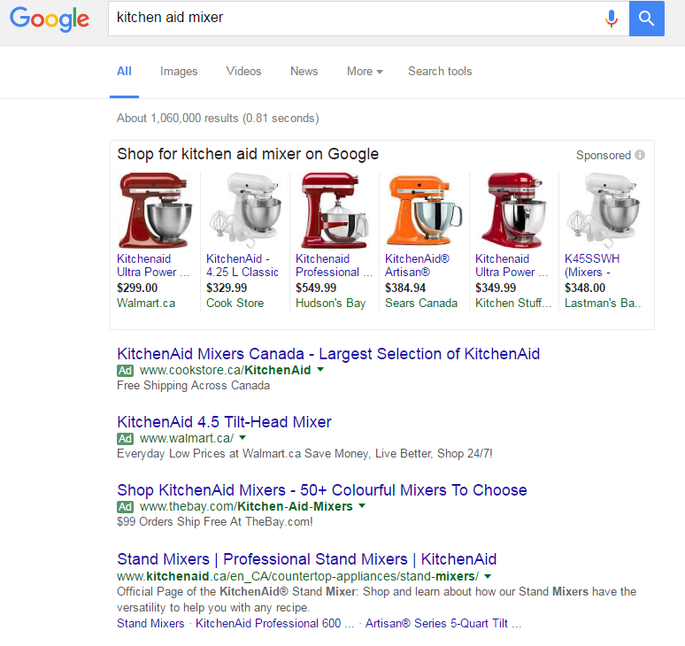

How does it work?
Pay-per-click (PPC) ads are one of the most popular methods of SEM. Pay-per-click campaigns allow a business to set a budget, and pay when people click on one of their ads. Ads are displayed for keywords the business has provided for their campaign.
Some keywords are more expensive than others, one reason being that there are more businesses bidding on the same keywords. It’s important to research and understand the value of keywords for your business and industry. Google has a helpful keyword planner as part of their pay-per-click platform, AdWords.
Most people starting out in SEM use cost-per-click bidding to pay for each click on their ads. With this option, you set a maximum cost-per-click bid (max. CPC bid). Your max. CPC bid is the highest amount that you're willing to pay for a click on your ad. Set your bid by thinking about how much an ad click is worth to you.

How to set up a paid ad?
Google and Yahoo Bing Network are two popular search engines that allow you to set up a search engine ad. To set up a Google Adwords campaign follow these steps:

- Sign up at www.adwords.google.com with your email and domain.
- Set your budget.
- Create your ad that will display in search engine results—be sure to incorporate keywords, reasons for the customer to buy from you, and a call to action (e.g., visit site to purchase online; call to book appointment).
- Select the keywords you would like to bid on.
- Enter your billing information, review all details, and post!

Use Google’s Keyword Planner to help choose the keywords you select to bid on. Google will give you information on average monthly searches, level of competition in your location, and suggested bid in dollar value.
After your ads have run for a while, evaluate which keywords are more effective in bringing in sales, using reports in your account.
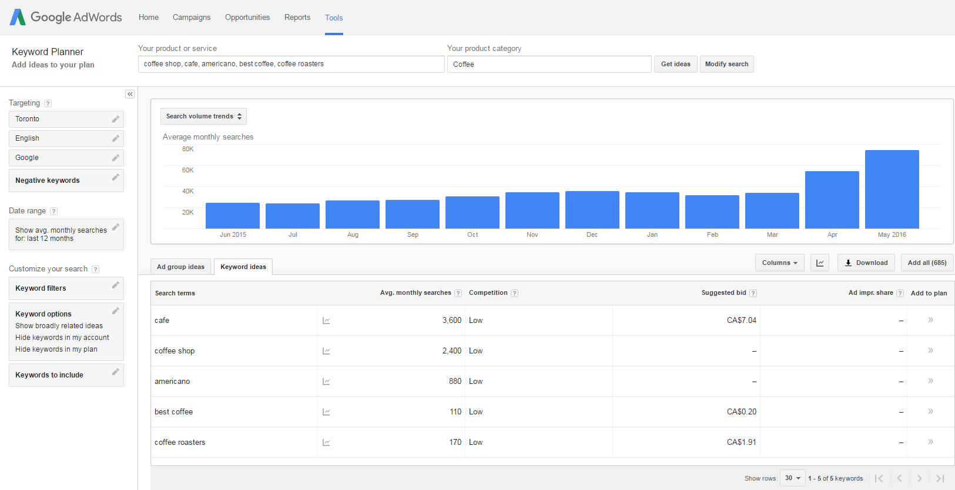

Social Marketing: Facebook®
Expand your reach by advertising on social media.
Facebook® Advertising is critical to connecting your business with people. With access to millions of active users, Facebook® can extend your reach to the right audience and location.
Facebook® has changed its model and algorithms to boost the impact of businesses advertising on Facebook®, and reportedly plans to dial down organic reach to as low as 1-2%. This means that your Facebook® Business Page is going to have a harder time showing up in newsfeeds without promoting your posts.
Facebook® Ads are placed in the stream of information people view on Facebook, to see your ads and take action.
The great thing about Facebook® Advertising is the ability to really pin point the audience you want to reach. Narrow your audience by targeting customers by:
- Location – specify a geographic radius to display your ads
- Age, gender
- Languages
- Interests, behaviors, connections
Similar to PPC, but often less expensive, Facebook® allows you to set budget maximums for your campaign, and provides useful analytics into the reach of your promoted posts, including “Impressions”, “Clicks” and “Likes”.
When starting out with a Facebook® Ads campaign, consider your main objective:
  - Clicks to Website – Drive qualified traffic to your site
  - Page Likes – Expand your online community
Your objective and audience will shape your ad content and call-to-action.
For more information or to get started, visit https://www.facebook.com/business/products/ads. You’ll first need a Facebook® for Business page, view the section below for more details.

Social Marketing: Instagram
Expand your reach by advertising on social media.
Instagram is a powerful, high-usage social platform, boasting over 600 million users.
For some industries, Instagram can be a hugely powerful platform to stay top of mind with customers. Instagram doesn’t currently differentiate between individual and business accounts, so your organic reach has greater potential. Instagram does use algorithms to tailor content to users based on the accounts and type of content they typically engage with.
Instagram is owned by Facebook®, and uses the same powerful advertising tools as Facebook®. That way, you can set up, run and track campaigns the same way you do with Facebook® ads. Both Facebook® and Instagram are constantly evolving and adding new features and options for advertisers.
The easiest way to run ads is by promoting posts you've shared on Instagram. Just select the post you want to promote, and then track how many people are seeing and interacting with your promoted post in the app.

Here's how to get started advertising on Instagram:

1. Create a Business Page and profile.
You must have a Facebook® Page to run ads and create a free Business Profile on Instagram. If you don't have one yet, create a Page.
2. Set up your ad.
Select your ad objective, target audience and ad format within Ads Manager or Power Editor.
3. Determine your budget.
Decide how long your ads will run and what budget you're comfortable with spending.
4. Publish.
Now that your ads are ready to go, hit publish. You'll get a notification when your ads are approved and ready to run.

Conclusion
Boosting your online presence is not difficult, all it requires is time and effort to address some of the elements that we have reviewed in this guide. By adding video and engaging content to your website, building out the backlinks, setting up social platforms as well as analytics and paid search marketing, you will surely see an uptake in website traffic and your bottom line as well.
Take action today. Make a plan and follow-through with it in order to maximize your website performance.

